**CellPortal**

**Project Title:** CellPortal

**Team Names:** Dawood Ashraf and Joshua Artavia

**Description:**

CellPortal is a development project that will be implemented using Java and MySQL. Its initiative is to efficiently store and retrieve data using MySQL that can be used in an everyday work environment for a cellular outlet store or franchise. Such database applications are already visible in everyday cellular outlet locations such as T-Mobile which need these database applications to store inventory, manage customer base, and keep record on employee data and sales. CellPortal will be limited to inventory and sales records as well as individual information storage and retrieval. CellPortal will not be for use in markets such as the food industry because it will not count for consumers and their feedback. CellPortal will simply be a transaction portal through which everyday transactions be it inventory purchase and sale can be carried out.

**Mission Statement:**

CellPortal's key objective is to productively and coherently organize data in a fashion that is easy to retrieve and manipulate. The main goal is to create a database application that can allow faster transactions with quick data processing insuring the client business can function at maximum efficiency.

**Mission Objectives:**

**-** Generate a task list containing all essentials aspects of the project.

**-** Put together a development plan that will allow quick prototyping to ensure that changes can be made on a regular basis.

**-** Program a working a prototype within first 4 weeks of project initialization.

**-** CellPortal during prototype phase be able to allow quick storage and retrieval of data of the required 7 entities.

**-** After prototype phase, test the delivery ready CellPortal to check and ensure it is a database application that is as bug free as possible.

**-** During test phase, ensure that CellPortal can be maintained easily and quickly as that is an important part of the software's life cycle.

---------------------------------------------------------------------------------------------

To maintain (enter, update, and delete) data on customer

To maintain (enter, update, and delete) data on stores

To maintain (enter, update, and delete) data on Sales representatives

To maintain (enter, update, and delete) data on managers

To maintain (enter, update, and delete) data on inventory (items)

To maintain (enter, update, and delete) data on return policies

To perform searches on transactions

To perform searches on stores

To perform searches on sales representatives

To perform searches on managers

To perform searches on inventory (items)

To perform searches on customers

To perform searches on return policies

To track the status of transactions

To track the status of inventory (item availability)

To track the status of stores (profit)

To report on transactions

To report on sales representatives

To report on managers

To report on stores

To report on customers

To report on inventory (items)

**Major user views:**

Sales Reps:

1. Enter Customer Information
2. Make Transactions
3. Item Search
4. Time Punch
5. Time Attendance Check
6. Transaction Amounts

Managers:

1. Enter Customer Information
2. Make Transactions
3. Item Search
4. Time Punch
5. Time Attendance Check
6. Time Attendance Edit
7. Transaction Amounts
8. Inventory (items)
9. Payroll
10. Hire Sales Representative

Owner:

1. Customer Information
2. Time Attendance Check
3. Item Search
4. Work Hours Check
5. Payroll
6. Transaction Amounts
7. Inventory (items)
8. Business Profit
9. Hiring Manager

|  |  |  |  |  |
| --- | --- | --- | --- | --- |
| **Data** | **Access** **Type** | **Owner** | **Manager** | **Sales Rep** |
| All Stores | Maintain |  |  |  |
|  | Query | X | X |  |
|  | Report | X | X |  |
| Single Store | Maintain |  | X |  |
|  | Query |  | X |  |
|  | Report |  | X |  |
| All Employees | Maintain |  |  |  |
|  | Query | X | X |  |
|  | Report | X | X |  |
| Single Employee | Maintain |  | X |  |
|  | Query |  | X |  |
|  | Report |  | X |  |
| All Customers | Maintain |  |  |  |
|  | Query | X | X |  |
|  | Report | X | X |  |
| Store Customers | Maintain |  | X |  |
|  | Query |  | X | X |
|  | Report |  | X |  |
| All Viewings | Maintain |  |  |  |
|  | Query | X |  |  |
|  | Report |  |  |  |
| Store Viewings | Maintain |  | X | X |
|  | Query | X | X | X |
|  | Report |  | X | X |
| All Inventory | Maintain |  |  |  |
|  | Query |  | X |  |
|  | Report |  |  |  |
| Store Inventory | Maintain |  | X |  |
|  | Query |  | X | X |
|  | Report |  | X |  |
| All Vendors | Maintain |  |  |  |
|  | Query | X |  |  |
|  | Report |  |  |  |
| Store Vendors | Maintain |  |  |  |
|  | Query | X | X |  |
|  | Report |  |  |  |
| Return Policy (All) | Maintain | X |  |  |
|  | Query | X |  |  |
|  | Report | X |  |  |
| Return Policy (Store) | Maintain |  | X |  |
|  | Query | X | X |  |
|  | Report |  | X |  |

|  |  |  |  |
| --- | --- | --- | --- |
|  | **Owner** | **Manager** | **Sales Reps** |
| Customer Information | X | X | X |
| Item Search | X | X | X |
| Time Punch | X | X |  |
| Time Attendance Check | X | X | X |
| Time Attendance Edit |  | X |  |
| Transaction Amounts | X | X | X |
| Inventory | X | X |  |
| Payroll | X | X |  |
| Business Profit | X |  |  |
| Hire Sales Representative |  | X |  |
| Hire Manager | X |  |  |

**Use Cases:**

Use Case Name: Hiring New Sales Representative

Actor/User: Manager

Steps:

1. User clicks on “New Sales Representative” button;
2. A new staff id is generated and displayed;
3. Prompt user to enter name, DOB, gender, job title, salary, phone number, emergency contact;
4. All information is displayed; ask for confirmation;
5. User clicks on “Confirm” button;

Use Case Name: New Customer

Actor/User: Sales Representative

Steps:

* 1. User clicks on “New Customer” button;
  2. Prompt the use to enter name, home address, phone number;
  3. All information is displayed and ask for confirmation;
  4. User clicks on “Confirm” button;

Use Case Name: Time Attendance Edit

Actor/User: Manager

Steps:

1. User clicks on “Time Attendance” button;
2. User clicks on “Edit Time” button;
3. User will be prompt to put his employee number and password
4. User clicks on the employee’s name;
5. User will change the time work for the employee;
6. User clicks on “Confirm” button;

User Case Name: Search Item

Actor/User: Client

Steps:

1. User goes to search bar
2. User types item’s name
3. User hit “Search” button

User Case Name: Inventory Search

Actor/User: Manager

Steps:

1. User will press button “Inventory”
2. User will type item type and model
3. Database will return a number of how many of that item available

User Case Name: Item Price

Actor/User: Client, Sale Rep, Manager

Steps:

1. User type in serach bar items type and model
2. List of phone given of that item with different memory size
3. Choose memory size
4. Price is shown

User Case Name:

**E/R Diagram**

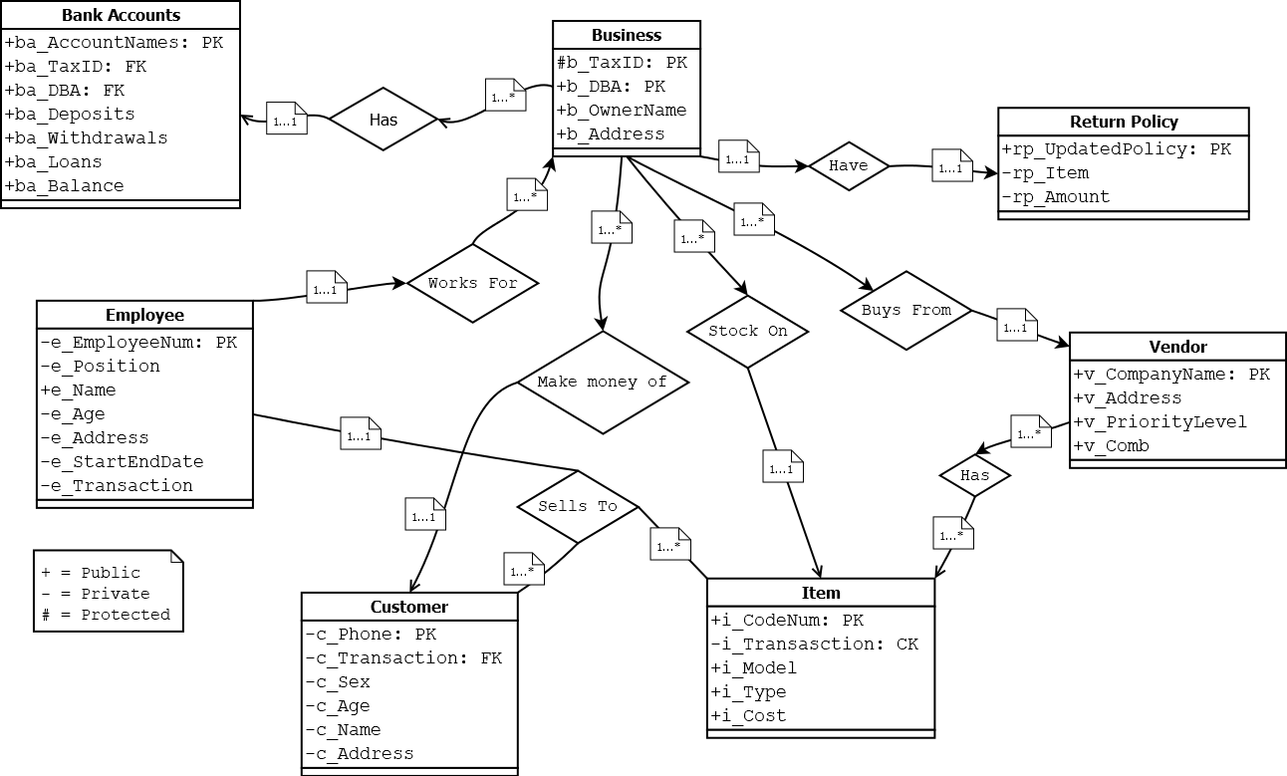

**Relational Model**

**Complete Database Functionalities & User Interface**

Actors:

Client

Sales Rep

Manager

Owner

Use Cases:

Web Interface:

**Use Case Realization**

**Database Prototype**

Platform & Software Tools:

How We Populated:

**Project Time Table**

|  |  |  |
| --- | --- | --- |
| **Major Tasks** | **Name** | **Time** |
| Complete E/R Diagram | Joshua Artavia | Completed:10/16/2018 |
| Relational Model | Dawood Ashraf | Completed: |
| Complete Database  Functionalities & User Interface | Joshua Artavia  Dawood Ashraf | Completed: |
| Use Case Realization | Joshua Artavia  Dawood Ashraf | Completed: |
| Database Prototype | Dawood Ashraf | Completed: |
| Project Time Table | Joshua Artavia | Completed: |